目录

 1

**2.6——调研——肌腱驱动机械臂：**



1. Is it possible to design a manipulator like AMBIDEX for vehicle manipulation?

Yes. I mean it is possible to design and install manipulator for vehicle manipulation. The number of manipulator is unknown. It is decided by the size and functions that vehicle manipulation needs. Totally design or we can buy some component directly? Shall I access some open source code?

1. Understand the structure of AMBIDEX. What is its advantages and drawbacks.

AMBIDEX 腱驱动机械手的混合动力学模型;

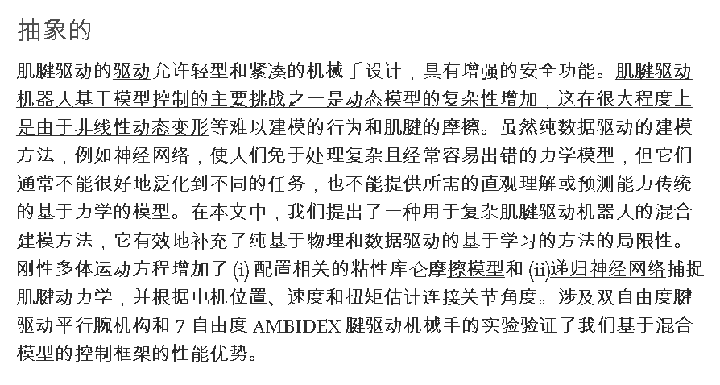



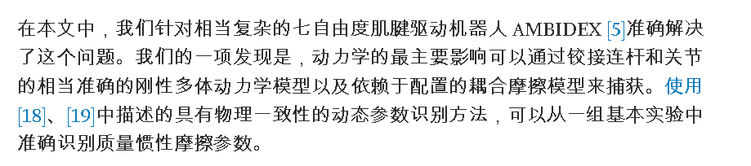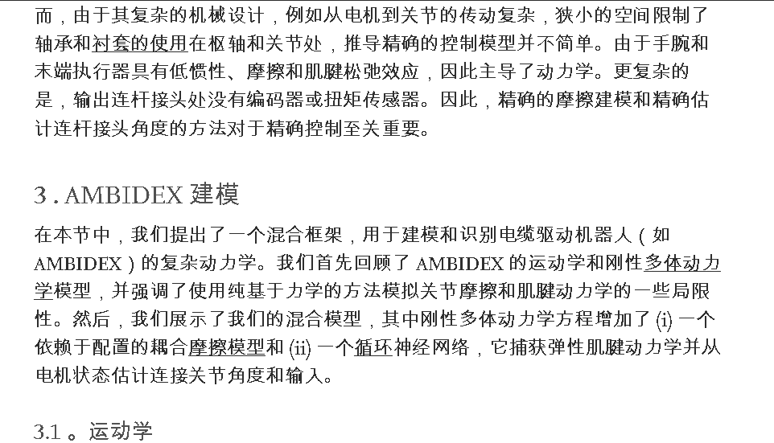

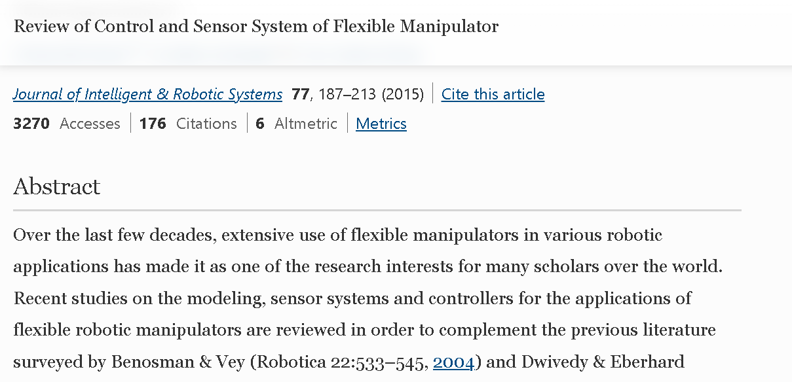

1. Is there any other types of manipulator can be applied for our application?

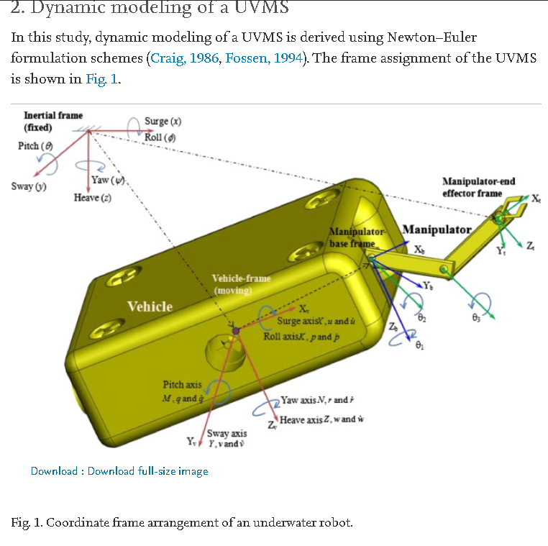

特斯拉蛇形机器人：

